

**Handwriting Policy**

1. **Principles**

All writers need the skills to put words onto the page and this must become as automatic a skill as possible as early as possible so that energies can move from transcription to composition.

The purpose of a clear handwriting policy is to enable all children to have the automaticity of transcription to allow them to write independently, accurately and creatively.

Our **aim** is forall children to have legible, fluent and joined handwriting by the end of Year 3.

**2.0 Practice**

Teachers will:

* Provide a clear and accurate model of school style of handwriting
* Teach handwriting explicitly and regularly
* Follow the Handwriting Programme of Study
* Follow the Transcription lesson plans (Years 1-6)
* Watch children form and then join letters until the habit is established
* Provide additional support where needed
* Ensure handwriting practice is mostly done at tables and in English books
* Ensure line spacing is suitable for all children
* Link to tricky words and/or spelling patterns where possible

Children will:

* Use correct, efficient pencil grip (use pencil grips for support if needed)
* Sit in correct position when writing
* Use the school style of handwriting
* Use pencil in Key Stage 1 (unless granted a pen licence). Use pen or pencil in Key Stage 2.

**3.0 Year Group Expectations**

Each year group is expected to build on the skills for the year before.

Nursery

* develop excellent fine and gross motor skills and control
* to develop correct pencil grip
* to write own first name (one capital, rest lower case)

Reception

* to have correct pencil grip
* to sit correctly at a table
* to form all lower case letters correctly
* to form all upper case letters correctly
* to work towards writing on 15mm lines by end of year

Year 1

* to form and use capital and lower case letters correctly
* to show appropriate positioning of letters on lines for ascenders, descenders and capitals
* to write digits 1 -9 correctly
* to use appropriate spacing between words
* to be able to write legibly on 15mm lines

Year 2

* to show more consistent spacing and relative proportions in sizing of letters
* to know all joins using Nelson joins (taught from autumn 2)
* to be joining their letters in line with taught content
* to be able to write legibly on 12mm lines (moving to 10 mm as appropriate)

Year 3

* to join using Nelson joins in most of their writing
* to show fluency and accuracy in joining
* to have consistency in sizing and spacing of letters
* to be able to write legibly on 10 mm lines

Year 4, 5, 6

* all children to be accurate in use of capitals and lower case
* all writing is joined, legible, fluent
* sizing, spacing of letters is consistent
* can make distinction in presentation for labels, headings, notes, published work
* to be able to write legibly on 10 mm lines

**4.0 Pen licences**

In Key Stage 1, a pen licence is awarded when children show that their writing is consistently

* neat
* joined
* appropriate relative sizing (including capitals, ascenders, descenders)
* accurate formation and joining

Children must maintain this level of skill and control to retain their pen licence.

When children reach Year 3, they can choose to write in pencil or pen (and be guided by their teacher to the most suitable implement).

**5.0 Resources**

* Triangular pencils for all in EYFS and Y1 (when pencil grip is secure, move to regular pencil)
* A variety of pencil grips available (SEND resources)
* Blue fibre-tip pens for those with pen licence in Key Stage One and Year 3 onwards
* Bespoke resources (linked to letter families and words to learn) in Year 1
* Programme of Study for handwriting
* Transcription lesson plans (Years 1-6)
* Nelson text books in each year group (Years 2-6)
* Handwriting booklets linked to Programme of Study for phonics (Reception)

**APPENDIX: HANDWRITING**

**1.HOW TO SIT A TABLE CORRECTLY**

Be at an uncluttered table **AND** have suitable writing implement.

Left handed writers ensure are on the left hand edge of table

(no one to bump arms with).

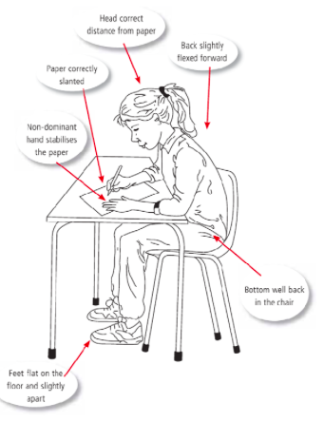

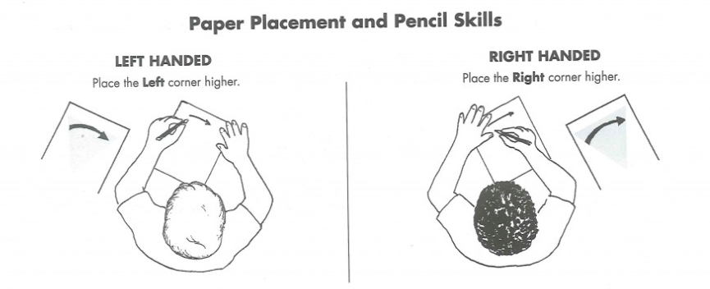

**2. CORRECT PENCIL GRIP**

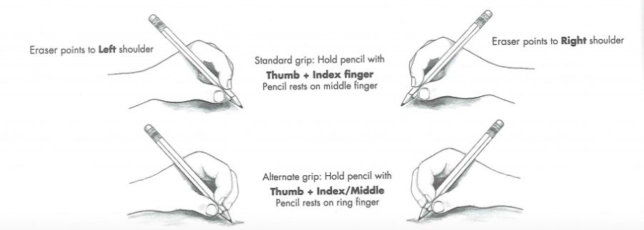

**3. Letters and numbers: School Style (Nelson)**

.

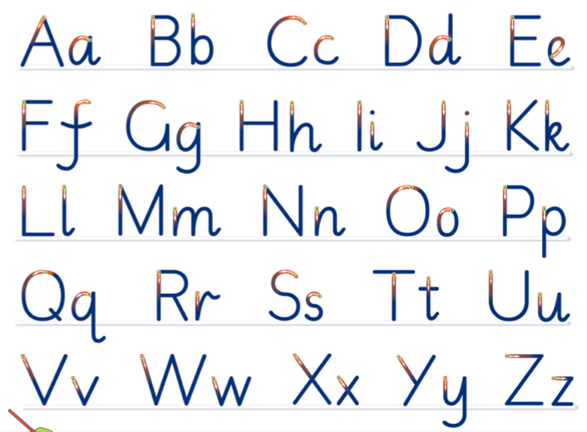

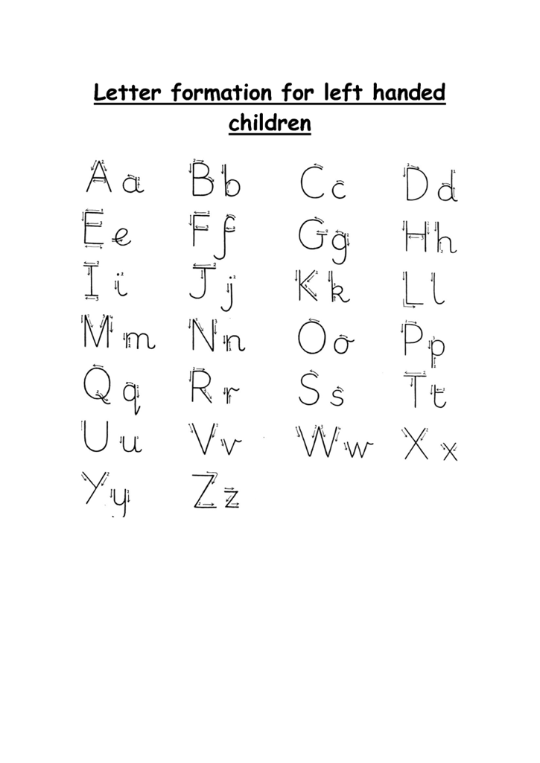

**4. Letter and number formation rhymes**



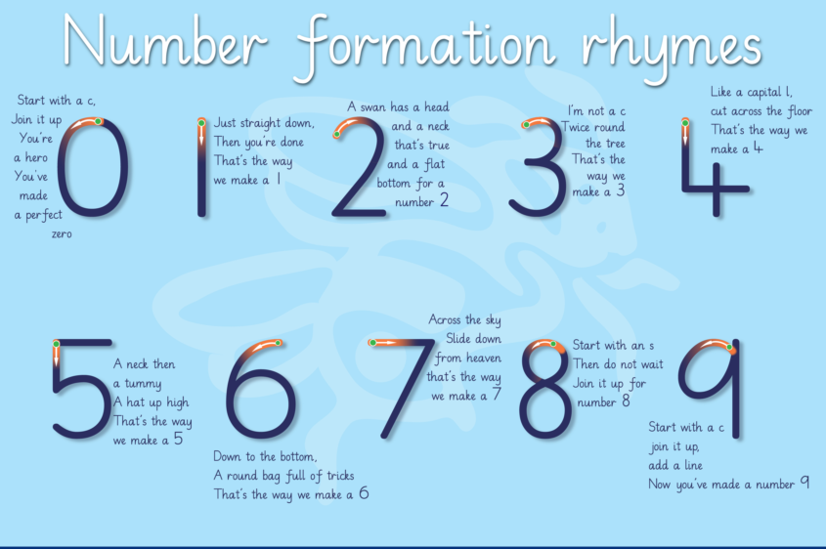

**5. The Four Joins**

1. FIRST JOIN (Diagonal Low Join)

to letters without ascenders e.g. in, am, on

1. SECOND JOIN (Diagonal Tall Join):

to letters with ascenders e.g. ab, ch, il

1. THIRD JOIN (Horizontal Low Join) :

to letters without ascenders e.g. wo, og, wi

1. FOURTH JOIN (Horizontal High Join):

to letters with ascenders e.g. wh, ob, al

**BREAK LETTERS: There are no joins from b g j p q x y z**