Use and impact of PE and Sport Premium funding for the 2020-21 academic year

Funding summary
The amount of PE and Sport Premium the school received for 2020-21 | £23,590
Amount carried over from 2019-20 (due to covid-19 pandemic and associated school closures) | £16,660
Total amount available for 2020-21 | £40,250
Total amount spent in 2020-21 (see report below for breakdown) | £14,292
Total amount to roll over to 2021-22 | £25,958
INTENT: Our approach to PE, sport and physical activity
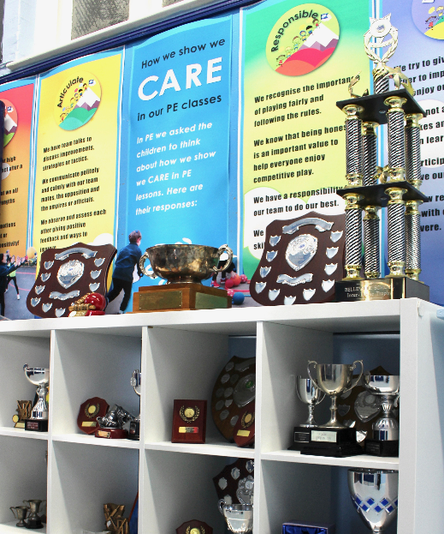
Belleville has a strong reputation for PE and sports and we strive to continuously develop this. Our wide ranging PE and sports provision is a key element of our whole school vision and ethos. We recognise the whole-school benefits for pupils’ engagement, behaviour and mental health, as well as parental attitudes and engagement with the school.
We want pupils to be excited and inspired by the wide range of activities, going far beyond the national curriculum. We also ensure a focus on fundamental movement skills that equip children with a foundation to participate in life long physical activity. To build participation from children with a range of ability and sporting ambition, we encourage them to try new things, find new interests and develop new skills and talents.
In recent years we have had a whole-school drive to develop a greater variety of physical activities throughout the school day, and to increase participation from specific groups, in particular those entitled to the pupil premium, those with SEND, and ‘reluctant engagers’.
Belleville participates in a range of local, regional and national sports initiatives, and we are a long-time member of our fantastic local school sports partnership which enables us to join borough-wide competitions, access staff training opportunities and develop links with other schools.
IMPLEMENTATION: What we delivered in 2020-21
This was a challenging year, impacted significantly by the covid-19 pandemic. Belleville was closed to the majority of pupils between January and March 2021, during the nationwide lockdown. Despite these challenges, we continued to develop our PE curriculum and to ensure that a broad range of sports and activities were made available to our children. We continually adjusted our approach to meet the needs of the children, investing in resources, equipment and new curriculum initiatives to ensure children remained active whether at home or at school.
During the closure period we integrated PE into our remote education, with innovative content from our PE team supplemented by external resources to support the physical and mental benefits of staying active.
Even when school was open there were significant restrictions on our PE and sport activity and no competitive school sports or clubs were able to run from September 2020 to May 2021. Plans were adapted with covid-19 guidelines in mind (consistent groups, space, fresh air, hygiene guidelines for equipment etc) and PE and sports were fully included in the school’s covid risk assessment.
Highlights from our active year, 2020-21:
- Skipping: Years 3 to 6 had their final sessions with our Skipping Workshops coach. We arranged extra training for our Skipping Captains, who encourage and support their peers to skip in the playground.
- Visitors: We took advantage of remote learning opportunities to arrange inspirational zoom ‘visits’ from Sophie Montagne (record-breaking ‘Ice Maiden’ ski team), Dermot Somers (mountaineer) and more.
- Summer of sport: We ran a number of free sports clubs in the summer term, daily on both of our school sites, encouraging children to try out new sports and be active with their peers.
- Year 6 flashmob: All Year 6 pupils performed an amazing surprise skipping/dancing routine for parents.

IMPLEMENTATION (continued): How we used our PE Premium funding in 2020-21
Key indicator 1: The engagement of all pupils in regular physical activity
Skipping: Skipping rope sets; skipping workshop for children.  Outdoor play: We purchased active playground specialist equipment for all year groups, to support play in ‘bubbles’ and to facilitate more child-led active play. We invested in street snooker to encourage independent and group play | £3545
Key indicator 2: The profile of PE, sport and physical activity being raised as a tool for school improvement
School CARE values: Work on displays to demonstrate importance of PESSPA to our school ethos.  Inspirational visits: We arranged zooms with high profile visitors in connection with activity/sports.  Communications: We continued to develop our website, communications and displays to promote PE/sports, encourage increased participation and boost parent engagement. | £500
Key indicator 3: Increased confidence, knowledge and skills of all staff in teaching PE and sport
Complete PE: We used this interactive resource to support curriculum improvements, planning, and resources, and to improve teachers’ knowledge of year-group appropriate sports and games.  Skipping training: We trained TAs and lunchtime staff to increase their knowledge and confidence to lead a variety of playground games, including French skipping, long rope skipping and double dutch. This also enabled skipping to be embedded into PE for warm ups, circuits and cool down. | £2453
Key indicator 4: Broader experience of a range of sports and activities offered to all pupils
Summer of Sports: To encourage children in being active, all children had access to multiple funded clubs before and after school. This significantly extended our existing provision.  Swimming: Provision in addition to our standard curriculum, exceeding national curriculum requirements. Swimming clinics during holidays. Supporting resources e.g. caps and goggles. | £7494
Key indicator 5: Increased participation in competitive sport
Inter-school events: We were not able to participate in tournaments this year due to covid-19 restrictions, but we continued our valuable membership of the local school sports partnership. | £300
Total spend | £25,958
IMPACT: The impact of our PE provision on physical activity, sports participation and attainment:
- Greater engagement in physical activities throughout the school day.
- Greater participation in sports by targeted groups of pupils (pupil premium, SEND and reluctant engagers).
- Professional skills development of both specialist and less experienced teachers.
- Pupils are better able to articulate how PE/sports connect with school values.
- New sports and activities have become part of ongoing provision.
- Links through local sports partnership have long term benefits
- Competitions establish a ‘legacy’, providing examples for future pupils of what they can achieve.
- Staff have greater confidence in using online resources/ICT tools/remote learning to strengthen curriculum.
- High quality, sustainable resources that will last well and benefit pupils for years to come.
Swimming proficiency:
As part of the funding agreement, we are required to report on the following for the 2020-21 Year 6 cohort:
Percentage of Year 6 cohort able to swim competently, confidently and proficiently over 25 metres |  | 88%
Percentage of Year 6 cohort able to use a range of strokes effectively (e.g. front crawl, backstroke) |  | 88%
Percentage of Year 6 cohort able to perform safe self-rescue in different water-based situations |  | 100%

